Project Plan

Group Number | Group 3

Group Name
Project Name | Project 12
Client | DISCE

project goals and objectives
Background
Briefly describe the context of the project and the activities of the sponsor/client (one or two paragraphs)
DISCE Ltd is a start-up oriented to helping other start-ups. Our project is to implement the business model canvas as a web-app for them.

The business model canvas is a relatively new method for reducing the previously forty page business plan template into a few pages of summarised information. It is currently done on paper in courses and classes, loan applications and to help refine the pitch of a company’s idea or product.

Metaphorically, it is the stress test of a product pitch prior to a brief dragons’ den style presentation.

The strength of a digitised web app for this business practise is the adaptability of such an online business model canvas. Alerting something such as the target market niche would ripple through the other areas and calculations of the canvas, easily allowing the user to see its effect on advertising money per capita, etc.

Objectives
We have been assigned the task of implementing a functional web-app that can store and retrieve data from a database.
Goals
Create secure and efficient database
Friendly and approachable UI
Attractive interface

Project scope
Project Deliverables
-A user will be able to create a user account.
-With a user account canvas pages can be created and will be linked to the user account.
-Canvas information must be storable and retrievable.
-User interface must be simple and functionality must be obvious at a glance.
-Webpages must load at a reasonable speed. This will require database access to be efficient.
-Accounts made on the website must be secure and a user must have the option of withholding some information within their canvas from the public.
Project Boundaries
In Scope  Users account creation  Canvas creation and linking with accounts  Enable user data to be storable and retrievable | Out of Scope  Track user content history  Suggest input  Provide tutorial to first time users

(Requirements and specifications documents to be included in Appendix 1 once completed)

Project approach

Initial Schedule
(Identify the stages and apply date ranges)
Stage | Description | Start | Finish | Duration
Research | Each member or the team will learn the languages required in the assigned roles | 20/01 | 29/01 | 9 days
Planning | Database plan to be designed and UI mock-up to be drawn | 30/01 | 06/02 | 7 days
Implementation | All expected functionality should be added to the project during this stage | 07/02 | 24/03 | 46 days
Refining | UI cleaned up and Project readied for handing over | 25/03 | 28/03 | 3 days

Milestones
(Identify Milestones in terms of date and also output/product. Milestones define critical points and achievements in the schedule and should refer to the goals and objectives)

05/02 – design website and database
10/02 – setup database and working forms submission
20/02 – account creation and sign-in working
05/03 – basic Business Model Canvas implemented
25/03 – improved UI and added functionality

Gantt Chart And Work Breakdown Structure
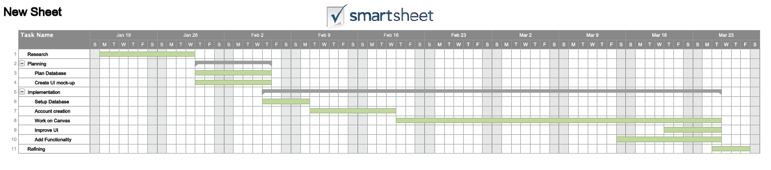

Project organisation

Roles and Responsibilities
(Identify the roles required for the project and assign Group Members to them. Outline their responsibilities)
Role | Group Member | Responsibility
Front-end Mentor and Usability Specialist | Daniel Lewis | Aid front-end developers
Content Manager and  Programmer | Thea Johnson | Create web content
Content Strategist and Content Contributor | Sean O Dwyer | Program webpages
Back-end Mentor and Project Manager | Killian McCabe | Aid back-end developers
Information Architect and Designer | Augustas Baublys | Implement database
Analytics Specialist and Coder | Peter Kelly | Code PHP

Staffing Chart
(Construct a hierarchical chart demonstrating lines of authority and management)
 | Front-end | Back-end
Mentor | Daniel Lewis | Killian McCabe
 | Thea Johnson  Sean O Dwyer | Augustas Baublys  Peter Kelly

Risk analysis

Risk Analysis
(Identify the risks to the successful conclusion of the project and calculate their Risk Factor)
Risk Element | Impact (1 to 5) | Likelihood (1 to 5) | Risk Factor (I*L)
Lack of prior experience | 2 | 4 | 8
Other Assignments | 3 | 4 | 12

Risk Mitigation
(Present the risks (ordered by their risk factor) and identify actions to reduce them)
Risk | Measures to Reduce Risk
Lack of prior experience | Extra time was given to research the languages and libraries required before we began implementation
Other Assignments | In meetings we will discuss when we expect to have a large up-and-coming assignment

Project controls
Outline the mechanisms to control the following factors (link to Roles and Responsibilities and Risk Analysis)
Factor | Control Method
Scope
Quality
Schedule

Communications

Client Communications
(Outline the schedule of meetings and any requested reports)
Meetings | Date | Purpose
Documents | Date Due | Description

Project Team Meetings
(Outline the schedule of team meetings and any requested reports)
Meetings | Date | Purpose
Documents | Date Due | Description

Appendices

Appendix 1 - Detailed Requirements and Specifications Documentation

Appendix 2 - Change Log

Appendix 3 – Meeting Minutes
Team and Client Meeting Minutes

Template (can be adapted but should contain the following elements)
- Basic information
  - Time, Date, Location
  - Attending, Apologies, Non-attending
- Agenda items (with results of discussions)
  - Review of agreed actions
  - Next actions
    - With assigned Names!
  - Matters arising
  - AOB
- Date & Time of next meeting

